**Nginx+keepalived**

# nginx的下载

# 安装nginx之前先安装依赖

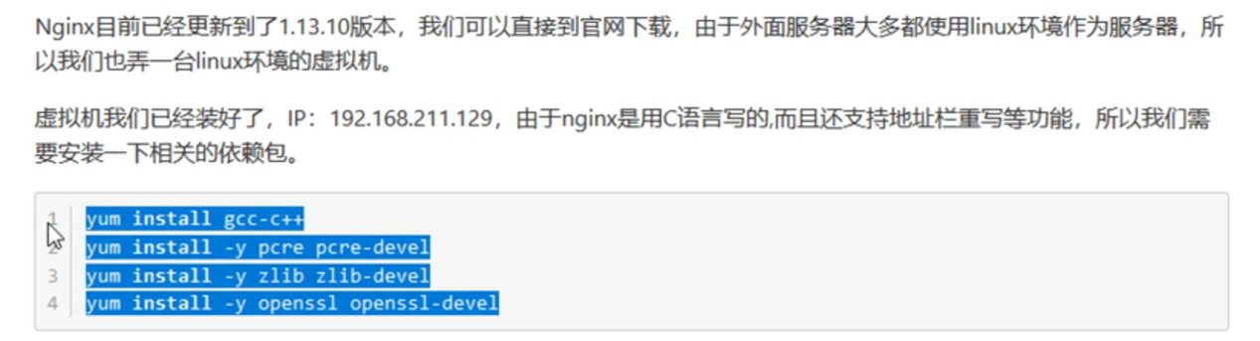

# nginx的安装

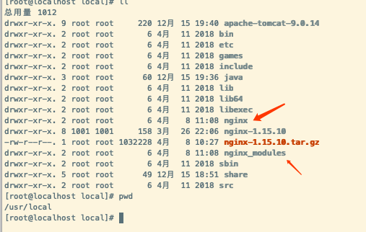

目录介绍：

1，nginx目录为正式安装的文件目录

2，nginx-1.15.10为解压目录，并没有正式安装

3，nginx_modules为第三方模块目录

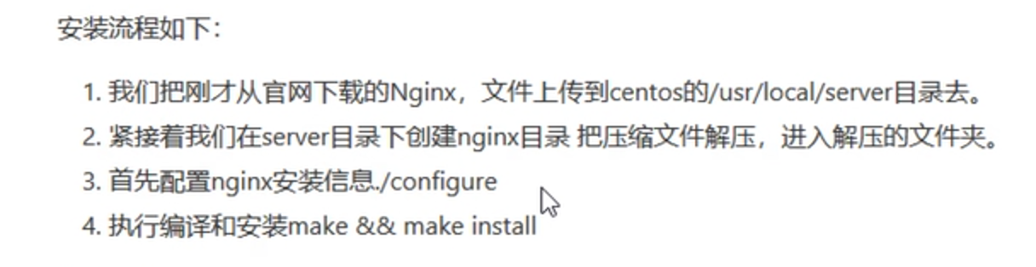

本机实际与视频演示目录地址不一样

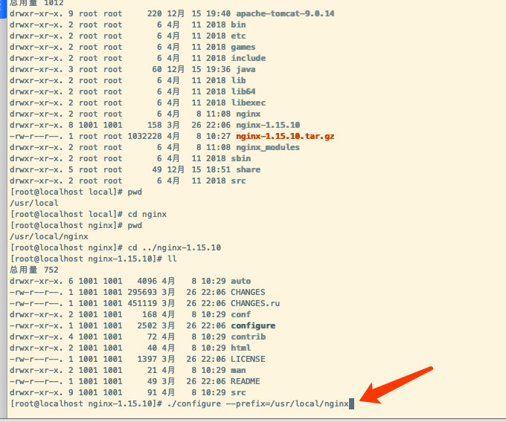

进行安装[root@localhost nginx-1.15.10]# ./configure --prefix=/usr/local/nginx  
添加对ssl证书的支持：./configure --with-http_ssl_module --prefix=/usr/local/nginx

继续执行命令：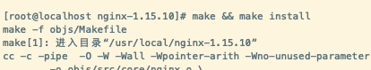

防火墙开放端口：

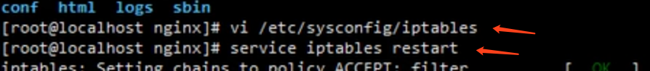

命令一：打开防火墙端口控制

命令二：重启防火墙

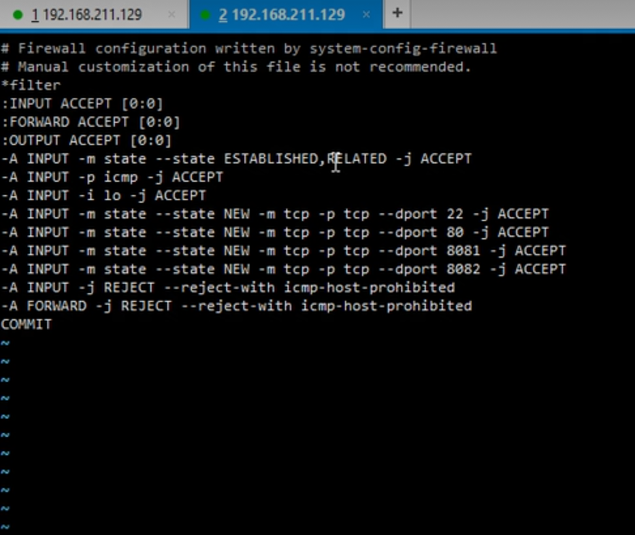

防火墙端口开发编写。

# nginx常用指令

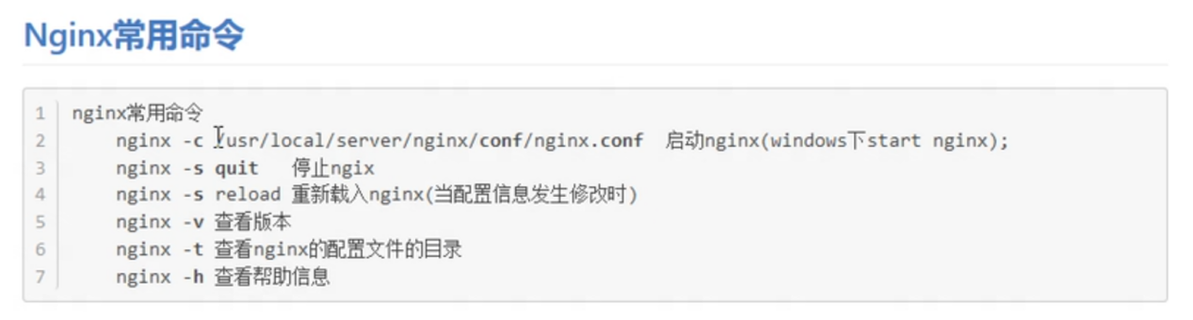

启动：进入nginx下的sbin文件夹，执行。/nginx命令即可

使用ip进行访问，出现如下即代表成功：

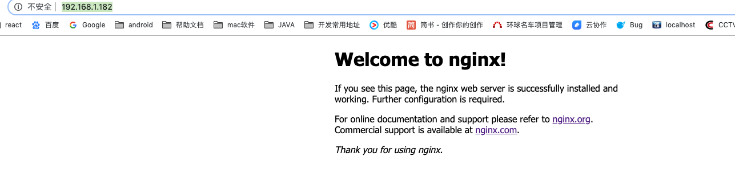

# 主模块

1，是否在后台运行



2，是否多线程运行

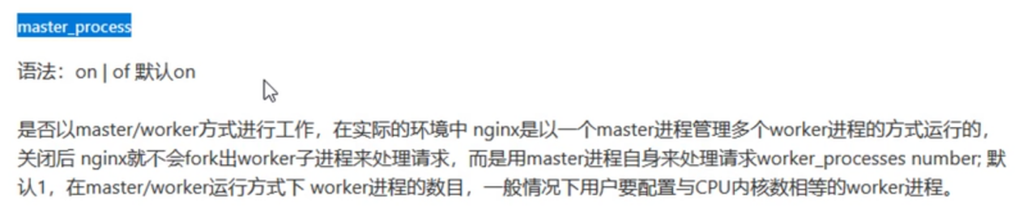

3，local规则：

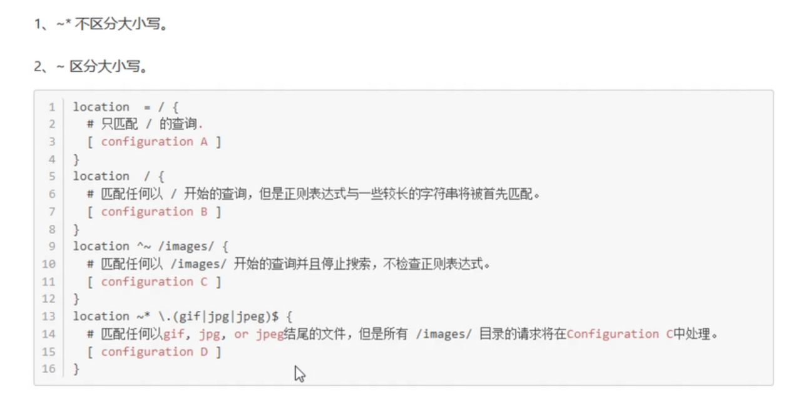

# http负载均衡模块

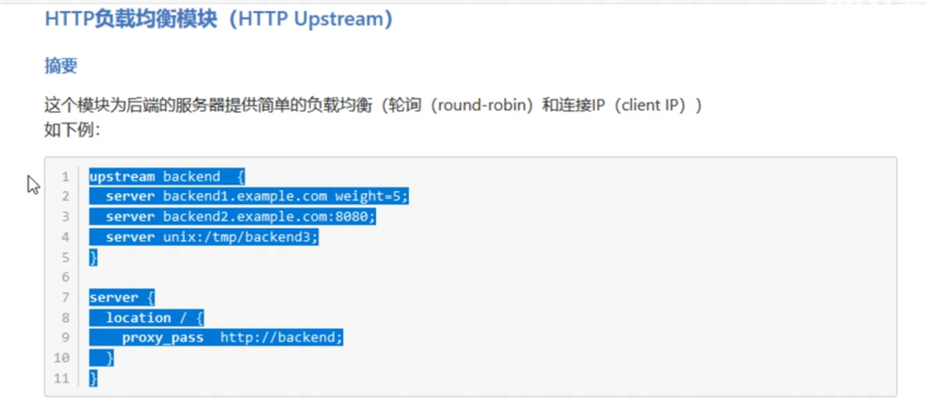

负载均衡池的概念。

可以写成如下：

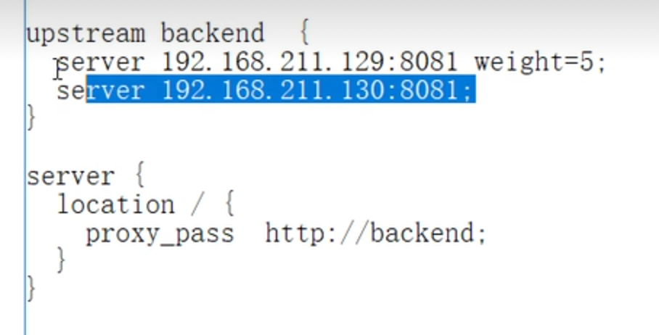

所有的请求转发给两台机器进行处理。

# 访问限制

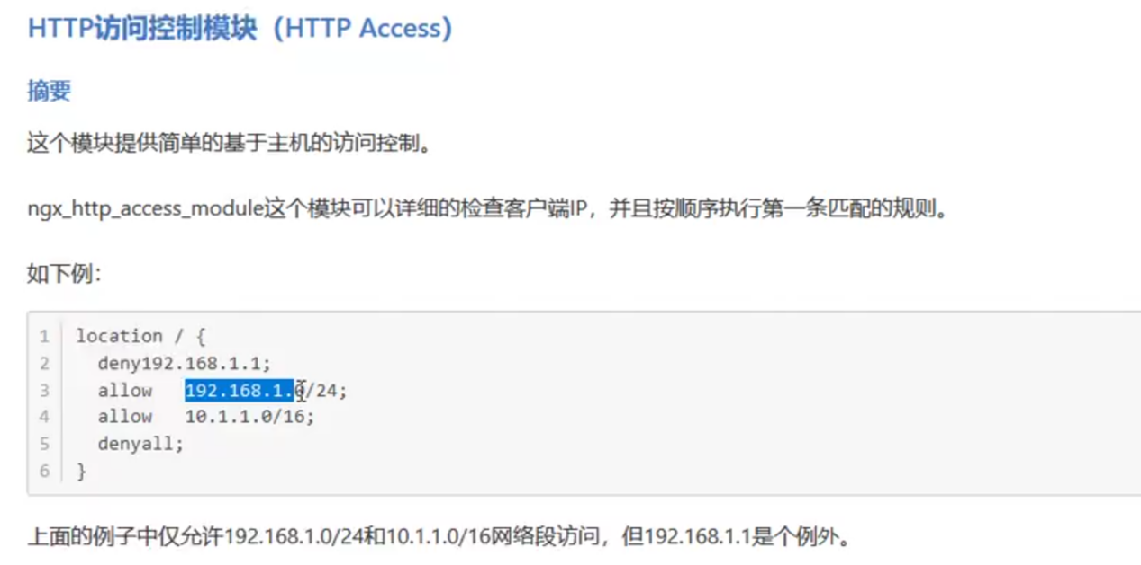deny禁止访问 denyall全部禁止

# 八、nginx+tomcat实现集群

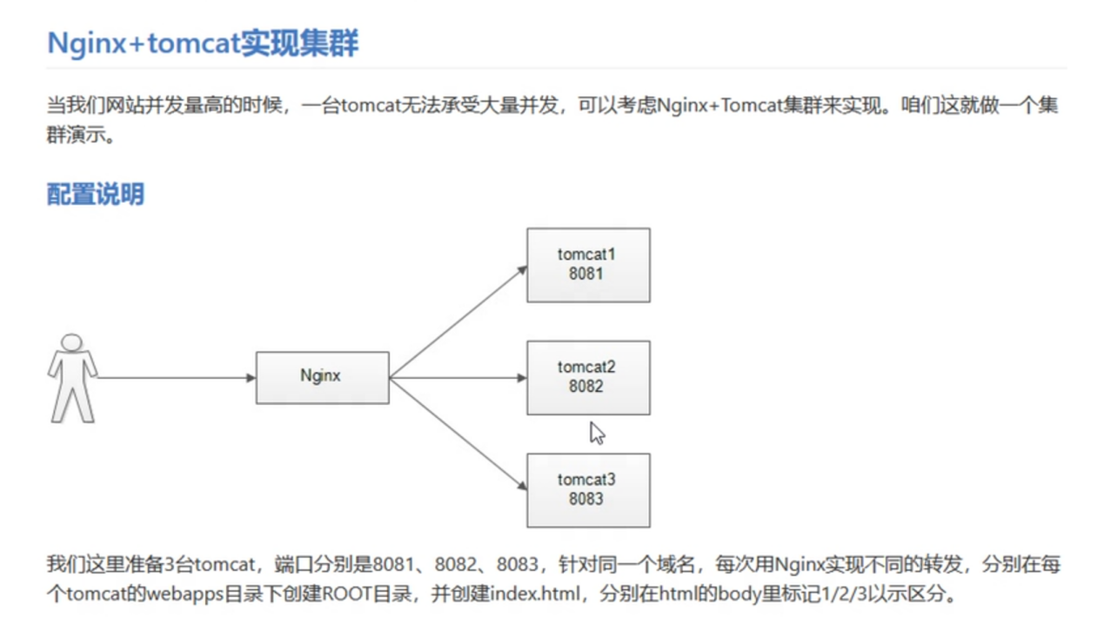

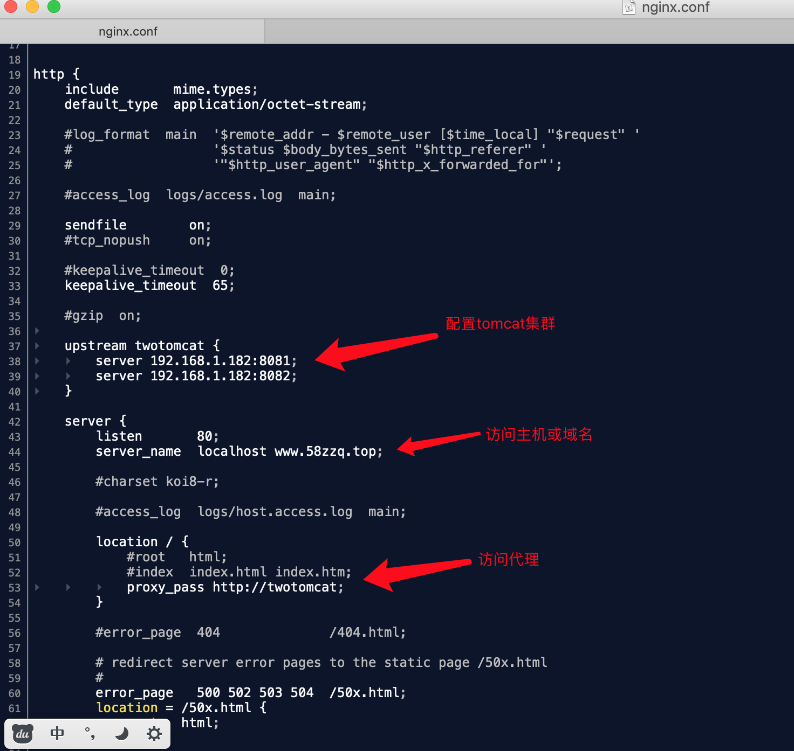

如上示例进行配置，访问如下：或访问：www.58zzq.top

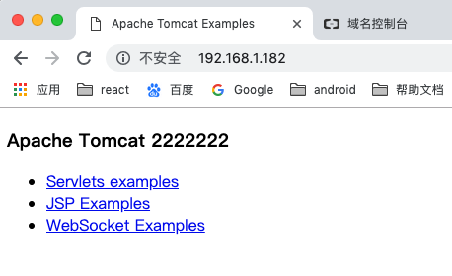

# nginx搭建图片服务器

1,在虚拟机上新建images文件夹并存入图片

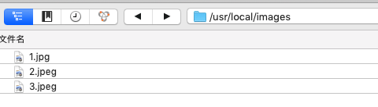

2，配置拦截的请求 【地址里不要加入images】

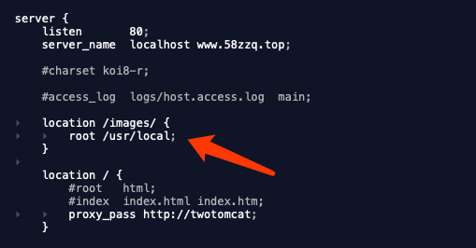

3，进行网络请求

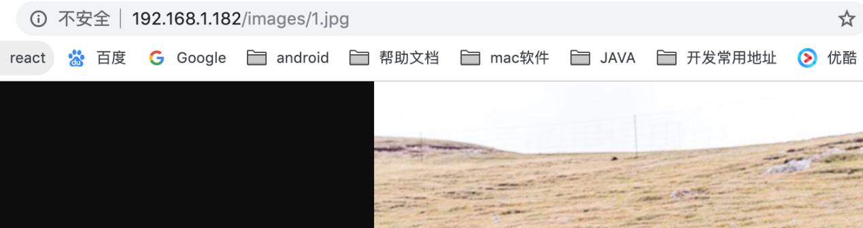

网络请求成功.

# keepalived+nginx

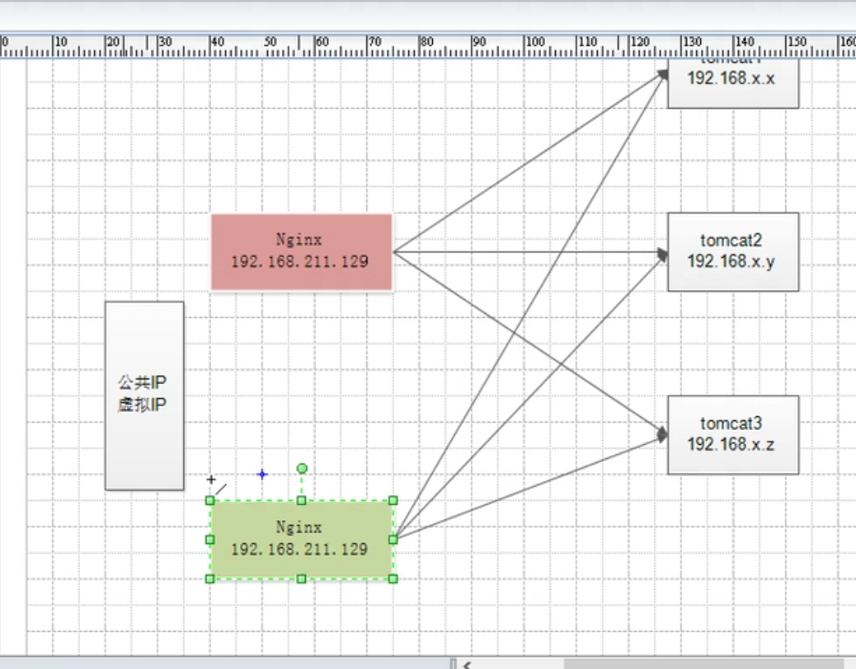

搭建两个nginx服务器，两个nginx服务器都配置多个tomcat的集群模式，最外层弄一个虚拟ip进行访问。

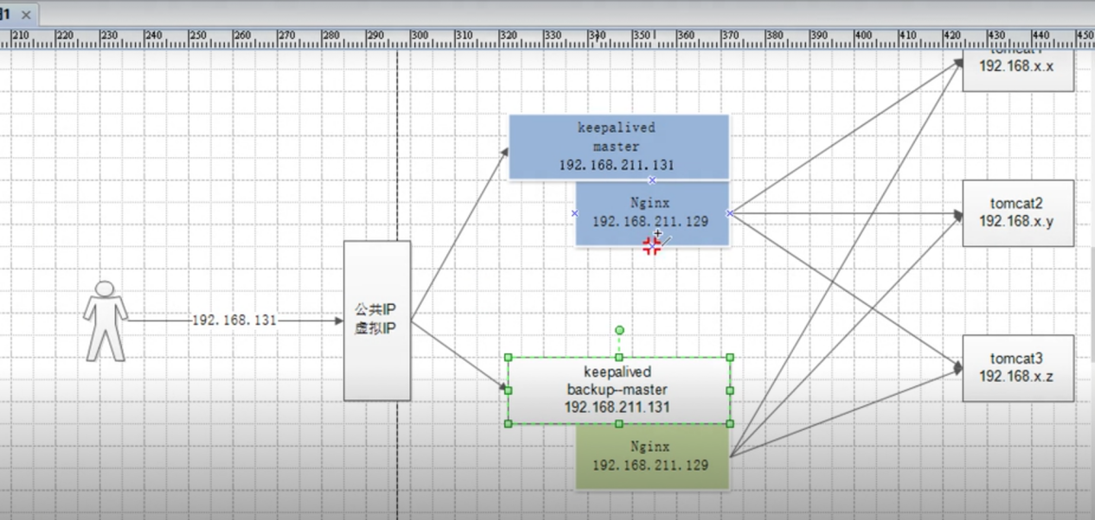

keepalived相当于路由，与对应的nginx进行绑定。

# keepalived安装

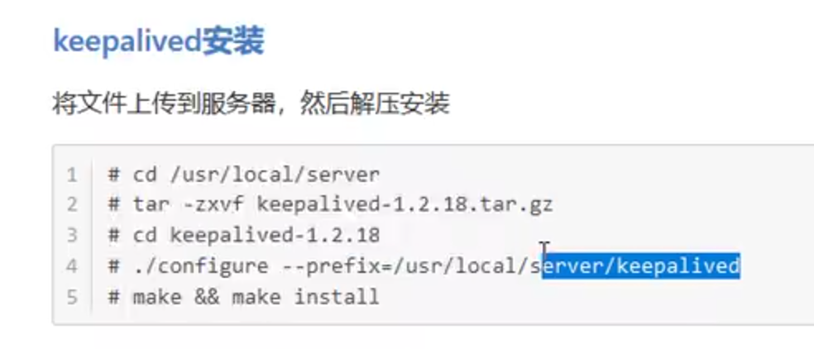

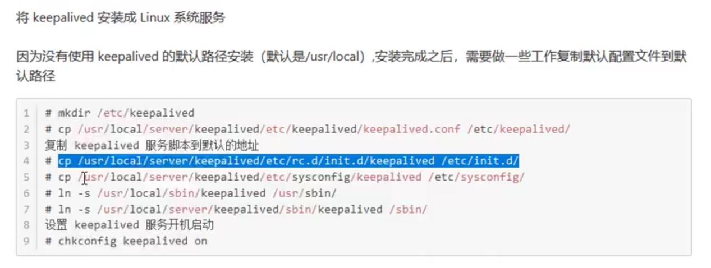

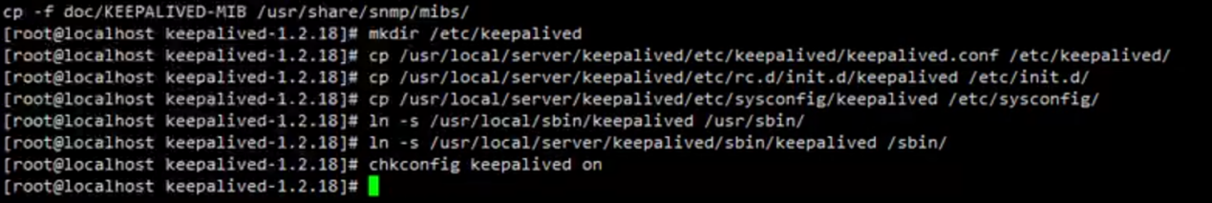

# nginx安装ssl正式及配置

到域名管理中心下载ssl正式：一个pen文件、一个key文件

然后放在nginx文件下：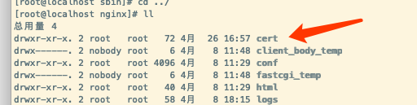

我这里放在nginx下的cert文件夹下（自己建的文件夹）

配置nginx.conf文件，如下：

|  |
| --- |
| #user nobody;  worker_processes 1;  #error_log logs/error.log;  #error_log logs/error.log notice;  #error_log logs/error.log info;  #pid logs/nginx.pid;  #daemon off/on是否后台运行  events {  worker_connections 1024;  }  http {  include mime.types;  default_type application/octet-stream;  #log_format main '$remote_addr - $remote_user [$time_local] "$request" '  # '$status $body_bytes_sent "$http_referer" '  # '"$http_user_agent" "$http_x_forwarded_for"';  #access_log logs/access.log main;  sendfile on;  #tcp_nopush on;  #keepalive_timeout 0;  keepalive_timeout 65;  #gzip on;    upstream twotomcat {  server 192.168.1.182:8081;  server 192.168.1.182:8082;  }  # another virtual host using mix of IP-, name-, and port-based configuration  #  #server {  # listen 8000;  # listen somename:8080;  # server_name somename alias another.alias;  # location / {  # root html;  # index index.html index.htm;  # }  #}  # HTTPS server  #  server {  listen 443 ssl;  server_name localhost www.58zzq.top;  #ssl on;  ssl_certificate ../cert/1108646_www.58zzq.top.pem;  ssl_certificate_key ../cert/1108646_www.58zzq.top.key;  ssl_session_cache shared:SSL:1m;  ssl_session_timeout 5m;  ssl_ciphers ECDHE-RSA-AES128-GCM-SHA256:ECDHE:ECDH:AES:HIGH:!NULL:!aNULL:!MD5:!ADH:!RC4;  ssl_protocols TLSv1 TLSv1.1 TLSv1.2;  ssl_prefer_server_ciphers on;  location / {  # root html;  # index index.html index.htm;  proxy_pass http://twotomcat;  }  }  server {  listen 80;  listen [::]:80;  server_name www.58zzq.top;  return 302 https://$server_name$request_uri;  }  } |

查看配置文件是否生效，如果为success则成功，报错需要修改。

|  |
| --- |
| $ nginx -t // 检查nginx配置文件 |

重启nginx

|  |
| --- |
| $ nginx -s reload // 使配置生效 |

访问你的域名，如下则表示成功。

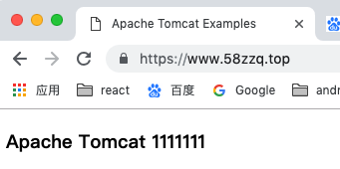

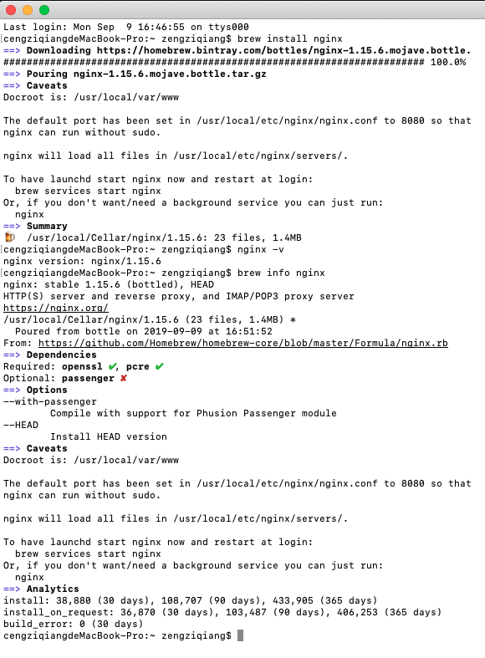

# nfc实现文件共享

Linux1：192.168.1.182

Linux2：192.168.1.249，有Nginx的服务器

两台机器都需要安装nfc和rpcbind

检查是否安装：rpm -qa|grep nfs

rpm -qa|grep rpcbind

安装命令：

yum -y install rpcbind nfs-utils

启动：

systemctl start rpcbind

systemctl start nfs

查看启动状态是否成功：

systemctl status nfs

systemctl status rpcbind

这里与 【/usr/local/images】文件夹为例

给权限：chmod 777 /usr/local/images

现在去Linux1上去操作，将Linux1上/usr/local/images文件夹里的文件共享到Linux2里，这样Linux2上的Nginx就可以访问到了。

【重点】在Linux1上操作：

vi /etc/exports

输入：/usr/local/images *(rw)

/usr/local/images *(insecure,rw,async,no_root_squash)

保存，重启使生效：exportfs -r

【重点】在Linux2上操作挂起：

mount -t nfs 192.168.1.182:/usr/local/images /usr/local/images

查看是否挂起成功：df

两个操作别弄反了 【<https://wenku.baidu.com/view/ffe239c2aa00b52acfc7ca36.html>

】

# nginx配置域名

## 原始配置文件

|  |
| --- |
| #user nobody;  worker_processes 1;  #error_log logs/error.log;  #error_log logs/error.log notice;  #error_log logs/error.log info;  #pid logs/nginx.pid;  events {  worker_connections 1024;  }  http {  include mime.types;  default_type application/octet-stream;  #log_format main '$remote_addr - $remote_user [$time_local] "$request" '  # '$status $body_bytes_sent "$http_referer" '  # '"$http_user_agent" "$http_x_forwarded_for"';  #access_log logs/access.log main;  sendfile on;  #tcp_nopush on;  #keepalive_timeout 0;  keepalive_timeout 65;  #gzip on;  server {  listen 80;  server_name localhost;  #charset koi8-r;  #access_log logs/host.access.log main;  location / {  root html;  index index.html index.htm;  }  #error_page 404 /404.html;  # redirect server error pages to the static page /50x.html  #  error_page 500 502 503 504 /50x.html;  location = /50x.html {  root html;  }  # proxy the PHP scripts to Apache listening on 127.0.0.1:80  #  #location ~ \.php$ {  # proxy_pass http://127.0.0.1;  #}  # pass the PHP scripts to FastCGI server listening on 127.0.0.1:9000  #  #location ~ \.php$ {  # root html;  # fastcgi_pass 127.0.0.1:9000;  # fastcgi_index index.php;  # fastcgi_param SCRIPT_FILENAME /scripts$fastcgi_script_name;  # include fastcgi_params;  #}  # deny access to .htaccess files, if Apache's document root  # concurs with nginx's one  #  #location ~ /\.ht {  # deny all;  #}  }  # another virtual host using mix of IP-, name-, and port-based configuration  #  #server {  # listen 8000;  # listen somename:8080;  # server_name somename alias another.alias;  # location / {  # root html;  # index index.html index.htm;  # }  #}  # HTTPS server  #  #server {  # listen 443 ssl;  # server_name localhost;  # ssl_certificate cert.pem;  # ssl_certificate_key cert.key;  # ssl_session_cache shared:SSL:1m;  # ssl_session_timeout 5m;  # ssl_ciphers HIGH:!aNULL:!MD5;  # ssl_prefer_server_ciphers on;  # location / {  # root html;  # index index.html index.htm;  # }  #}  } |

## 配置域名后的文件

|  |
| --- |
| #user nobody;  worker_processes 1;  #error_log logs/error.log;  #error_log logs/error.log notice;  #error_log logs/error.log info;  #pid logs/nginx.pid;  events {  worker_connections 1024;  }  http {  include mime.types;  default_type application/octet-stream;  #log_format main '$remote_addr - $remote_user [$time_local] "$request" '  # '$status $body_bytes_sent "$http_referer" '  # '"$http_user_agent" "$http_x_forwarded_for"';  #access_log logs/access.log main;  sendfile on;  #tcp_nopush on;  #keepalive_timeout 0;  keepalive_timeout 65;  #gzip on;  upstream ip_port{  server localhost:8088;  }  server {  listen 80;  server_name localhost linux.iszengziqiang.club; # 多个域名用空格隔开  #charset koi8-r;  #access_log logs/host.access.log main;  location / {  root html;  index index.html index.htm;  proxy_pass http://ip_port;  }  #error_page 404 /404.html;  # redirect server error pages to the static page /50x.html  #  error_page 500 502 503 504 /50x.html;  location = /50x.html {  root html;  }  # proxy the PHP scripts to Apache listening on 127.0.0.1:80  #  #location ~ \.php$ {  # proxy_pass http://127.0.0.1;  #}  # pass the PHP scripts to FastCGI server listening on 127.0.0.1:9000  #  #location ~ \.php$ {  # root html;  # fastcgi_pass 127.0.0.1:9000;  # fastcgi_index index.php;  # fastcgi_param SCRIPT_FILENAME /scripts$fastcgi_script_name;  # include fastcgi_params;  #}  # deny access to .htaccess files, if Apache's document root  # concurs with nginx's one  #  #location ~ /\.ht {  # deny all;  #}  }  # another virtual host using mix of IP-, name-, and port-based configuration  #  #server {  # listen 8000;  # listen somename:8080;  # server_name somename alias another.alias;  # location / {  # root html;  # index index.html index.htm;  # }  #}  # HTTPS server  #  #server {  # listen 443 ssl;  # server_name localhost;  # ssl_certificate cert.pem;  # ssl_certificate_key cert.key;  # ssl_session_cache shared:SSL:1m;  # ssl_session_timeout 5m;  # ssl_ciphers HIGH:!aNULL:!MD5;  # ssl_prefer_server_ciphers on;  # location / {  # root html;  # index index.html index.htm;  # }  #}  } |

## 改动部分

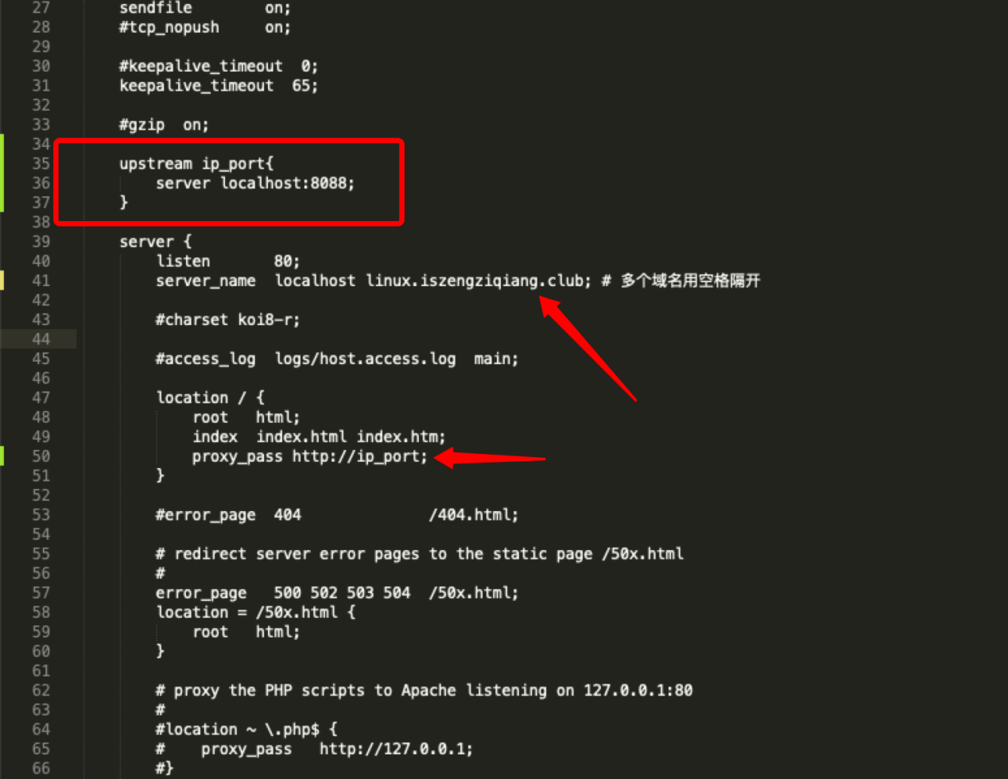

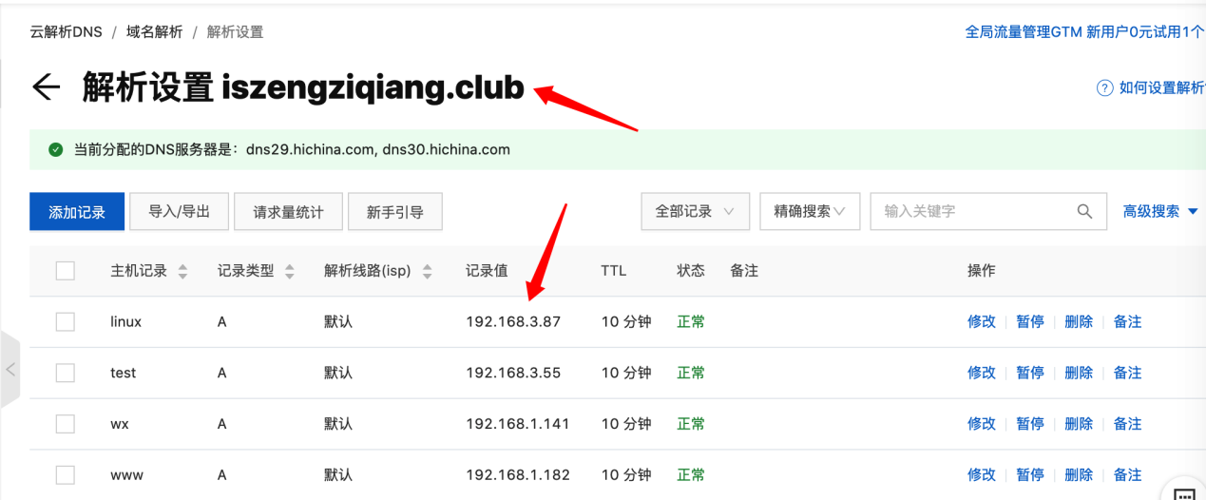

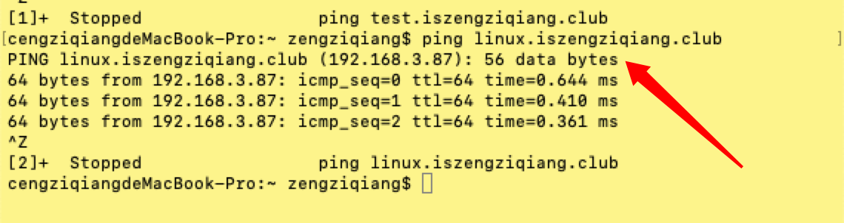

## 准备一个8088端口的项目

端口和测试接口

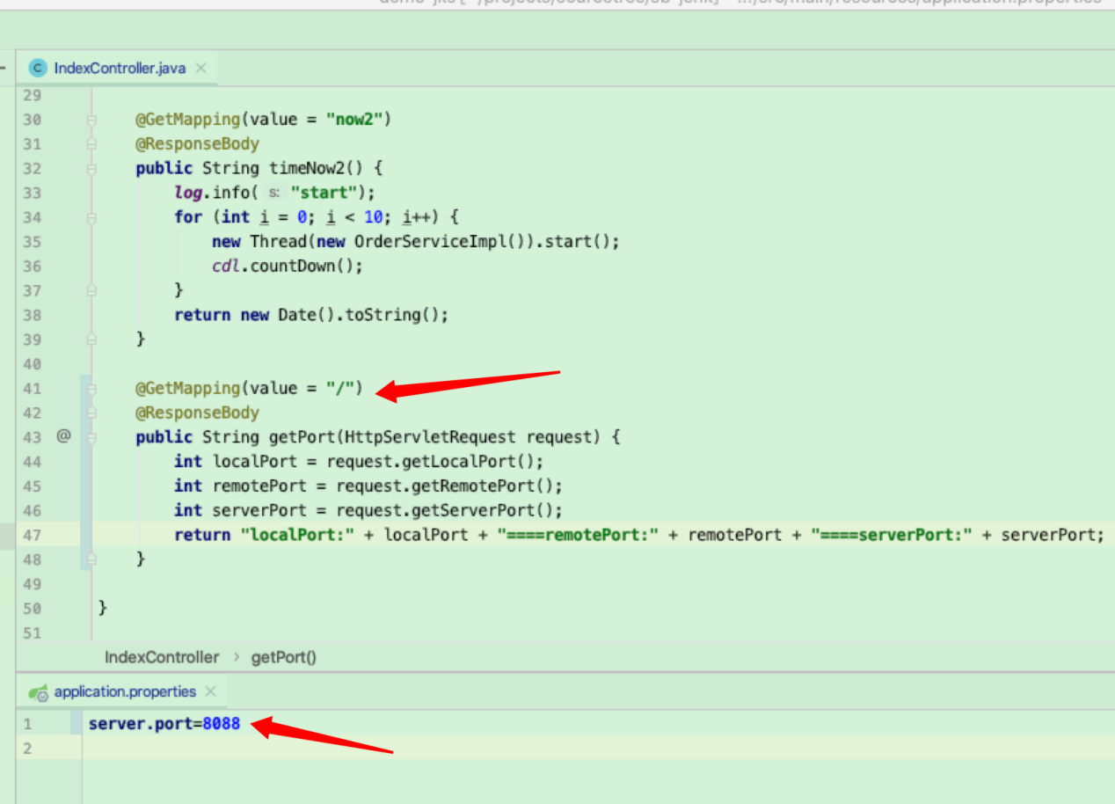

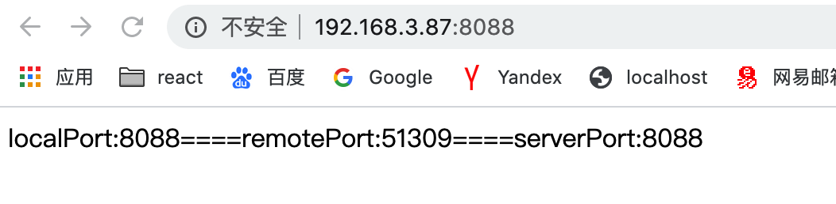

项目能正常访问

## 启动Nginx

启动：进入nginx下的sbin文件夹，执行。/nginx命令即可

或者带配置文件启动方式：/usr/local/nginx/sbin/nginx -c /usr/local/nginx/conf/nginx.conf

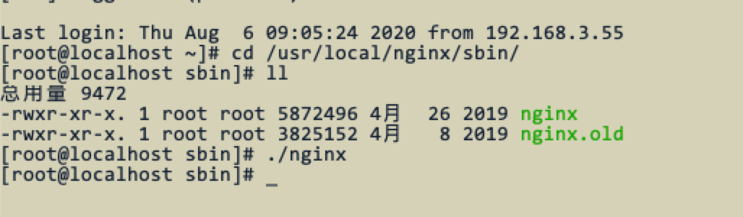

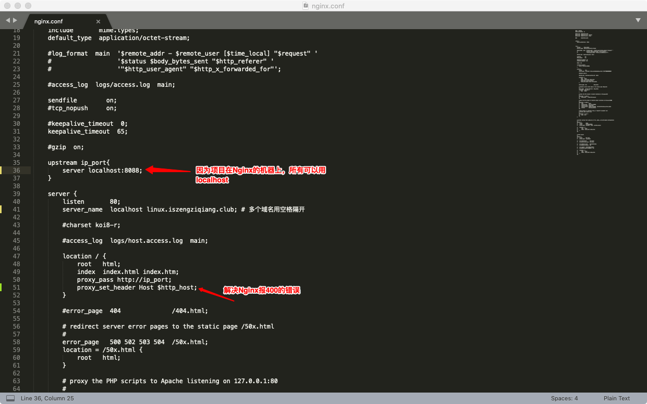

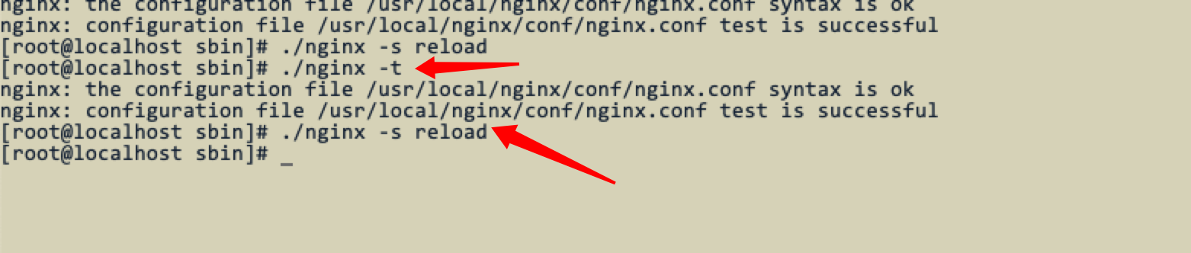

检测和重启命令

运行成功后的样子：

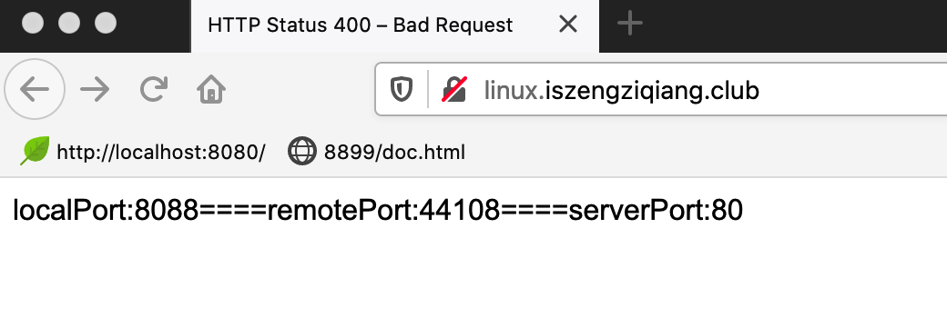

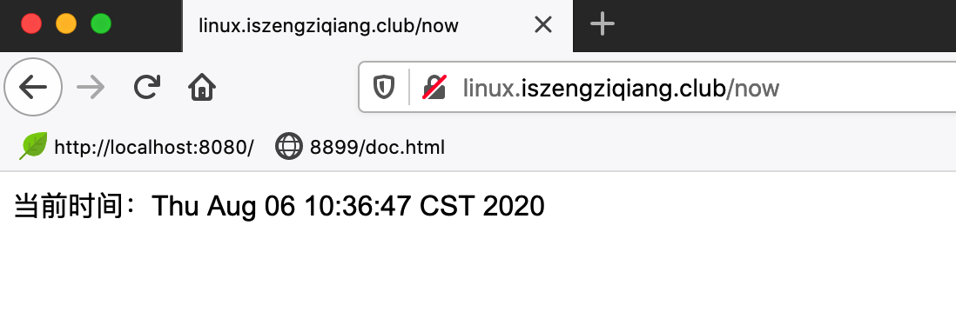

到这里就成功了。

## 配置负载均衡

现在有一个192.168.3.87:8088项目，然后我们在部署一个192.168.3.70:8089项目

两个项目不在同一个机器上,先运行看项目效果

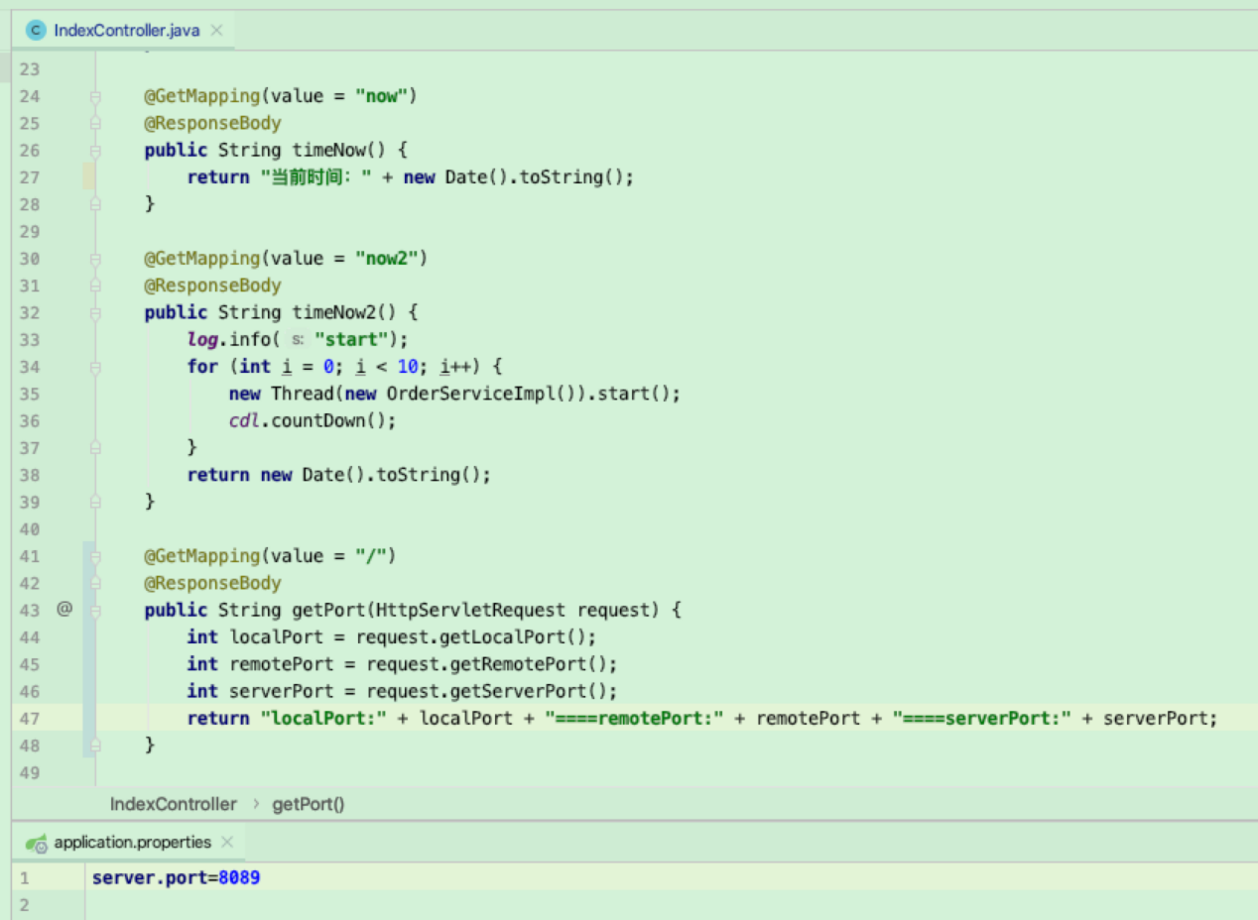

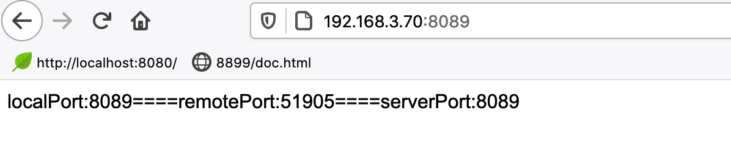

项目能正常运行。

配置Nginx配置文件：

|  |
| --- |
| #user nobody;  worker_processes 1;  #error_log logs/error.log;  #error_log logs/error.log notice;  #error_log logs/error.log info;  #pid logs/nginx.pid;  events {  worker_connections 1024;  }  http {  include mime.types;  default_type application/octet-stream;  #log_format main '$remote_addr - $remote_user [$time_local] "$request" '  # '$status $body_bytes_sent "$http_referer" '  # '"$http_user_agent" "$http_x_forwarded_for"';  #access_log logs/access.log main;  sendfile on;  #tcp_nopush on;  #keepalive_timeout 0;  keepalive_timeout 65;  #gzip on;  upstream ip_port{  server localhost:8088;  server 192.168.3.70:8089;  }  server {  listen 80;  server_name localhost linux.iszengziqiang.club; # 多个域名用空格隔开  #charset koi8-r;  #access_log logs/host.access.log main;  location / {  root html;  index index.html index.htm;  proxy_pass http://ip_port;  proxy_set_header Host $http_host;  }  #error_page 404 /404.html;  # redirect server error pages to the static page /50x.html  #  error_page 500 502 503 504 /50x.html;  location = /50x.html {  root html;  }  # proxy the PHP scripts to Apache listening on 127.0.0.1:80  #  #location ~ \.php$ {  # proxy_pass http://127.0.0.1;  #}  # pass the PHP scripts to FastCGI server listening on 127.0.0.1:9000  #  #location ~ \.php$ {  # root html;  # fastcgi_pass 127.0.0.1:9000;  # fastcgi_index index.php;  # fastcgi_param SCRIPT_FILENAME /scripts$fastcgi_script_name;  # include fastcgi_params;  #}  # deny access to .htaccess files, if Apache's document root  # concurs with nginx's one  #  #location ~ /\.ht {  # deny all;  #}  }  # another virtual host using mix of IP-, name-, and port-based configuration  #  #server {  # listen 8000;  # listen somename:8080;  # server_name somename alias another.alias;  # location / {  # root html;  # index index.html index.htm;  # }  #}  # HTTPS server  #  #server {  # listen 443 ssl;  # server_name localhost;  # ssl_certificate cert.pem;  # ssl_certificate_key cert.key;  # ssl_session_cache shared:SSL:1m;  # ssl_session_timeout 5m;  # ssl_ciphers HIGH:!aNULL:!MD5;  # ssl_prefer_server_ciphers on;  # location / {  # root html;  # index index.html index.htm;  # }  #}  } |

修改如下，其他都不改：

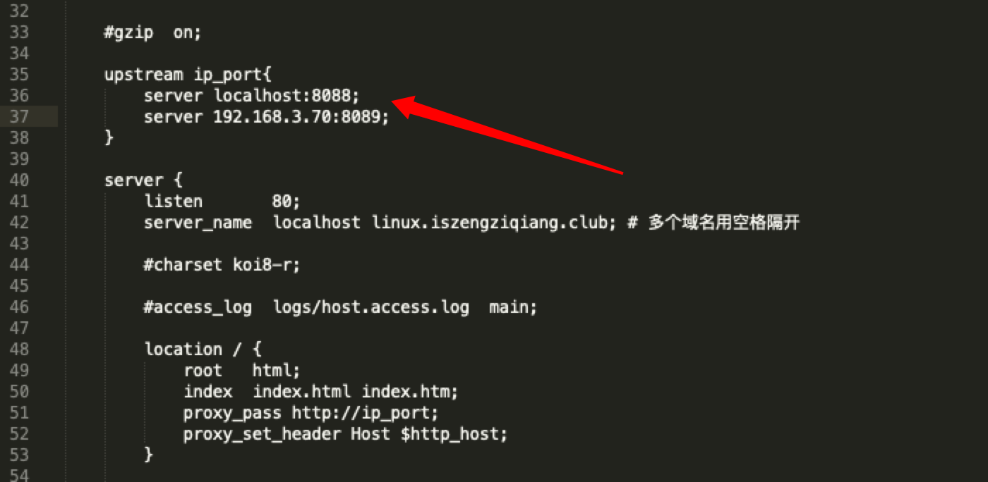

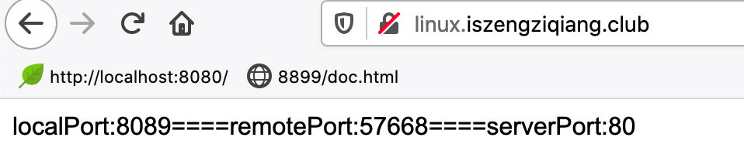

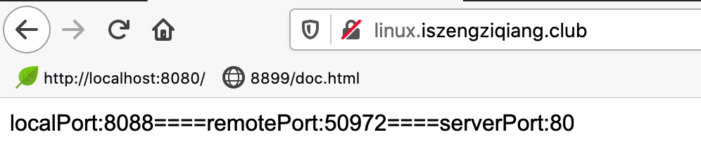

运行效果：访问域名，出现不同的端口即可表示成功。

# Nginx配置跨域访问

Nginx配置跨域访问，需要安装【headers-more-nginx-module】插件，插件安装博客

<https://blog.csdn.net/weixin_45716993/article/details/102880755>

记住，千万不能make install，不然会覆盖config的文件。

# Nginx外网访问内网IP地址

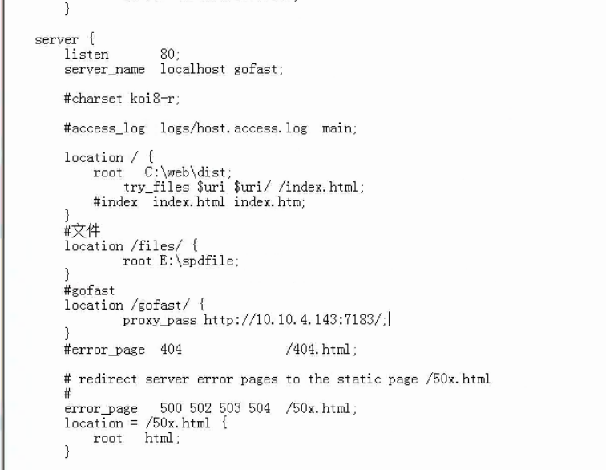

如图所示，外网用http://61.184.24.254:50006/ 映射了http://10.10.4.143:80/端口，即80端口对外网放开。

然后用外网http://61.184.24.254:50006/gofast/ 访问内网的http://10.10.4.143:7183/ 上。

及内网只能访问http://10.10.4.143:7183/ ，外网是无法访问这个地址的。

如上配置 location /gofast/ {} 的方式，结尾必须有斜杠

如下：

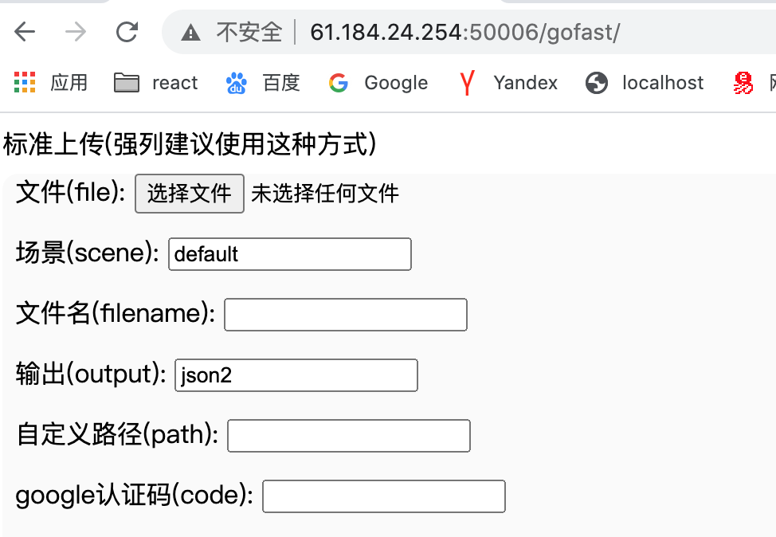

访问这个地址就可以转到内网的

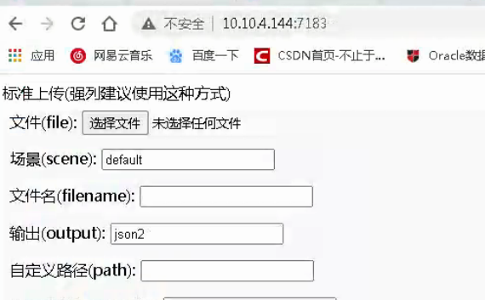

这个就是内网的网页

# 上传图片大小限制

#上传限制100M

client_max_body_size 100M;

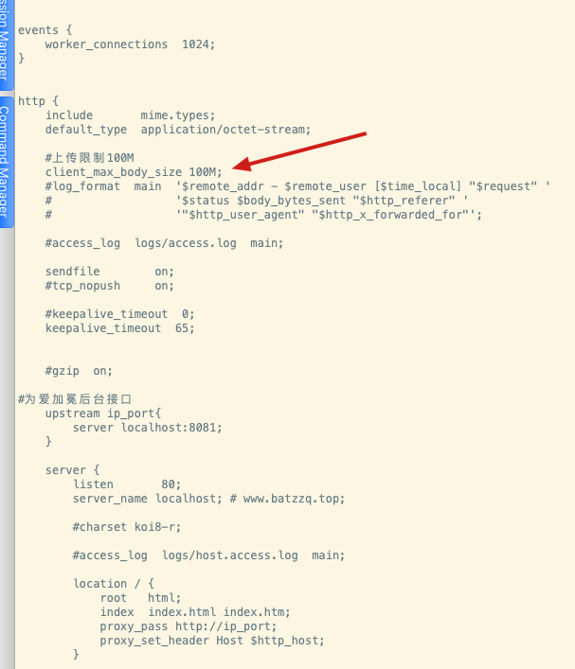

# vue

#陆勤教保

server{

listen 8899;

server_name localhost;

root /lqjb/dist;

location / {

try_files $uri $uri/ /index.html;

}

}

## 解决跨域访问

|  |
| --- |
| location / {  root html;  index index.html index.htm;  proxy_pass http://ip_port;  proxy_set_header Host $http_host;  # 指定允许跨域的方法，*代表所有  add_header Access-Control-Allow-Methods *;  # 预检命令的缓存，如果不缓存每次会发送两次请求  add_header Access-Control-Max-Age 3600;  # 带cookie请求需要加上这个字段，并设置为true  add_header Access-Control-Allow-Credentials true;  # 表示允许这个域跨域调用（客户端发送请求的域名和端口）  # $http_origin动态获取请求客户端请求的域 不用*的原因是带cookie的请求不支持*号  add_header Access-Control-Allow-Origin $http_origin;  # 表示请求头的字段 动态获取  add_header Access-Control-Allow-Headers $http_access_control_request_headers;  if ($request_method = OPTIONS){  return 200;  }  } |

